**Microwave Wearable Antenna for brain tumour Sensing Analysis System**

**ABSTRACT:**

Wearable antenna are used f­­or body wearing electronic devices such as watches due to its body wearing idea of these type devices these devices should be made upon low radiating towards the body because of tissue affection on the body here a body wearable microwave antenna is made to analyse the radiation over the body using this sensing of the radiation detected tumour affection on a particular part of the body (head) is analysed and detected in the combination of the microwave analysis.

**CHAPTER 1**

**INTRODUCTION**

**OVERVIEW**

In this rapid changing world in wireless communication systems, multiband antenna plays an important role for wireless service requirements. The current trend in commercial and government communication systems have been to develop low cost, minimal weight, low profile antennas that are capable of maintaining high performance over a large spectrum of frequencies. Through the years, slotted microstrip patch antenna structure are the most common option used to realize millimeter wave monolithic integrated circuits for microwave, radar and communication purposes. With in this operating range of frequency, the antenna should have stable response in terms of gain, radiation pattern, polarization etc. At the same time it should be of small size, conformal, low cost and should be easily integrated into the RF circuits.

Slotted microstrip patch antenna can also be printed directly onto circuit board. Since the slotted microstrip patch antenna requires few materials, it is low cost, easy to manufacture and light weight. These characteristics make slotted microstrip patch antennas ideal for use in cell phones and other small electronic devices. Slotted microstrip patch antenna consists of a dielectric substrate, with a ground plane on the other side. Due to its advantages such as low weight, low profile planar configuration and capability to integrate with micro wave integrated circuits technology, the slotted microstrip patch antenna is very well suited for applications such as wireless communication systems, cellular phones, pagers, radar systems and satellite communication systems.

The size of the slotted microstrip patch antenna is inversely proportional to its frequency. For this reason, slotted microstrip patch antennas are generally used for ultra-high frequency signals. Slotted microstrip patch antenna is capable of sensing frequencies lower than microwave would be too large to use.

With the rapid development of modern communication and semiconductor technologies, a wide variety of wireless service have been successfully introduced worldwide in the past few years. Antenna plays a vital role in any wireless communication. A well designed antenna relaxes the complexity and improves the performance of the receiver. The dimension, type and the configuration of the antenna depends on the application and the operating frequency.

**CHAPTER 2**

**LITERATURE REVIEW**

* **Microwave System for Head Imaging**

A wideband microwave system for head imaging is presented. The system includes an array of 16 corrugated tapered slot antennas that are installed on an adjustable platform. A switching device is used to enable the antennas to sequentially send a wideband 1–4 GHz microwave signal and capture the backscattered signals. Those signals are recorded using suitably designed virtual instrument software architecture. To test the capability of the system to detect brain injuries, a low-cost mix- ture of materials that emulate the frequency-dispersive electrical properties of the major brain tissues across the frequency band 1–4 GHz are used to construct a realistic-shape head phantom. A target that emulates a realistic hemorrhage stroke is fabricated and inserted in two different locations inside the fabricated head phantom. A preprocessing algorithm that utilizes the symmetry of the two halves of human head is used to extract the target response from the background reﬂections. A post-processing confocal algorithm is used to get an image of the phantom and to accurately detect the presence and location of the stroke.

* **Dual-Polarized, Broadside, Thin Dielectric Resonator Antenna for Microwave Imaging**

We present a design for a dielectric resonator antenna (DRA) with dual-polarization characteristics. This antenna is de- signed for use in a three-dimensional(3-D)microwave to mography system to collect co-polar and cross-polar responses. The broadside radiation and dual polarization are achieved by exciting the fundamental mode of the DRA as well as by using two elements of the DRA that are perpendicular to each other. Compared to the conventional rectangular DRA, the proposed antenna is reduced in size by a factor of 6.7. The proposed DRA offers a measured bandwidth of 72% (2.6–5.52 GHz). The performance and radiation characteristics of the antenna are veriﬁed experimentally.

* **A Compact Double-Layer On-Body Matched Bowtie Antenna for Medical Diagnosis**

A compact double-layer Bowtie antenna optimized for medical diagnosis is presented in this paper. This on-body antenna is matched to the human body to allow more energy to be radiated into the human body to obtain stronger reﬂections for image processing. By using a Bowtie antenna with double layers as well as a folded structure and meandered micro strip lines at the bottom of the antenna, a small size of 30 30 mm with a size reduction of 40% is achieved, compared to the reference antenna of 50 50 mm within the same operational frequency range. After the optimization of the antenna parameters, the antenna is characterized from 0.5 to2 GHz, where the low frequencies enable a high penetration into human body and the large frequency range contributes to a high bandwidth and hence a ﬁne range resolution. The simulated and measured results are shown with respect to the impedance matching, near-ﬁeld pattern, gain and SAR distributions. With features such as a very small size, very low operational frequency, high front-to-back ratio, this design shows a high potential for use in medical diagnosis of stroke, breast cancer and water accumulation detection in the human body.

* **Bandwidth Enhancement of a Microstrip-Line-Fed Printed Wide-Slot Antenna With a Fractal-Shaped Slot**

Microstrip-line-fed printed wide-slot antenna with a fractal- shaped slot for bandwidth enhancement is proposed and experimentally studied.Byetchingthewideslotasfractalshapes,itisexperimentallyfound that the operating bandwidth can be signiﬁcantly enhanced, and the relation between the bandwidth and the iteration order (IO) and iteration factor (IF) of the fractal shapes is experimentally studied. Experimental results indicate that the impedance bandwidth, deﬁned by 10 dB reﬂection coefﬁcient, of the proposed fractal slot antenna can reach an operating bandwidth of 2.4 GHz at operating frequencies around 4 GHz, which is about 3.5 times that of a conventional microstrip-line-fed printed wide-slot antenna. It also achieved a 2-dB gain bandwidth of at least 1.59 GHz.

* **Wideband Unidirectional Antenna of Folded Structure in Microwave System for Early Detection of Congestive Heart Failure**

A three-dimensional antenna based on a combination of loop and dual mono pole structures with parasitic elements is presented. The antenna is speciﬁcally designed for a microwave system aimed at the early detection of congestive heart failure. The antenna is ﬁrst designed as a planar structure and then folded over optimally deﬁned folding lines to properly alter the path and phase of the surface currents for a unidirectional radiation and compact size as needed for the detection system. A prototype antenna of size (where, is the wavelength of the lowest resonant frequency) is developed to cover the band required in the targeted application. The measured results indicate 53% fractional bandwidth (580 – 1000 MHz), 6-8 dB front to back ratio, and 3-5 dBi gain. The antenna is then used to build a heart failure detection system, which also includes a compact microwave transceiver, a processing and image re- constructionalgorithmbasedonthesyntheticaperturefocusingtechnique, and a display unit. The system is used to successfully detect an early case of congestive heart failure in an artiﬁcial torso phantom that includes the main torso organs.

**1.3 PROBLEM FORMULATION**

From the literature survey analysis, the study reveal that existing work shows the increased return loss, and VSWR. Gain total is also considerably needed to be increased. Frequency coverage is only for three frequency bands are generated.

The drawbacks present in the available antennas can be identified as Less reception of due to high return loss due to single patch antenna are used for each individual device.

Not compatible for future multiband antenna system applications. Each antenna requires each of them a separate processor to execute the particular data reception operation.

**1.4 OBJECTIVE**

* To design a single band antenna for biomedical purpose.
* To achieve VSWR less than 2, to obtain optimum return loss and radiation pattern.
* To determine and compare the performance of microstrip patch antennas with microstrip feed line and coaxial feed line techniques.

**1.5 ORGANISATION OF THE PROJECT REPORT**

Chapter 1 deals with the overview of the project, literature survey, problem formulation, objective of the project.

Chapter 2 presents the basic theory of patch antenna, including the basic structure, feeding techniques and characteristics of the patch antenna. Then the performance parameters with its expressions to compare the various antenna structures have been discussed. Finally to find the dimensions of the conventional patch antenna are presented in this chapter.

Chapter 3 details about the microstrip patch antenna for biomedical applications. The simulation results about the patch antenna using Computer Simulation Technology (CST) Software have been discussed. Then about Hardware description also discussed.

Chapter 4 concerts on the concluding remarks with the scope of future work.

**CHAPTER 2**

**MICROSTRIP PATCH ANTENNA**

**2.1 INTRODUCTION**

A microstrip antenna consists of a metallic pattern on one side of a dielectric substrate and ground plane on the other side of the substrate. In this project I have focused on making a microstrip patch antenna. Figure 2.1.1 shows a microstrip patch on the dielectric substrate.

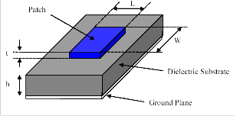

**Figure: 2.1.1 Structure of a microstrip patch antenna**

The antenna patch can have different shapes, but is most likely rectangular. In order to make performance predictions the rectangular patch antenna has the following parameters, where λ0 is the wavelength in vacuum also called the free-space wavelength. *Length(L)*:0.3333λ0<*L*<0.5λ0, *Height(h)*: 0.003λ0 ≤ *h ≤ 0.05*λ0, *Thickness (t)* : *t <<*λ0, *Dielectric constant ()*: 2.2 ≤ ≤ 12, In electromagnetic radiation λ is often given instead of λ0as the speed of light in vacuum is very close to the speed of light I air.

As described later in this chapter the length of the patch is very important when it comes to the radiation. Looking at the parameters of the length, the length is slightly less than λ/2. That is because the microstrip patch antenna is constructed on the theory based on one-half wavelength.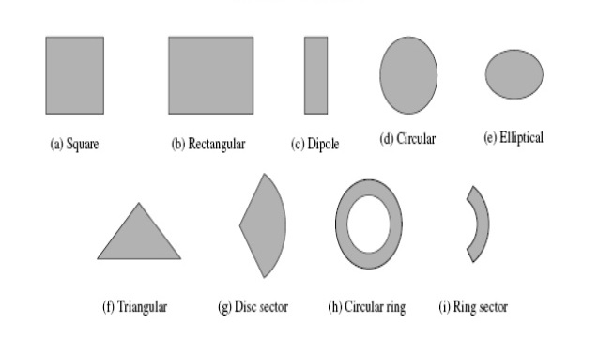

**Figure: 2.1.2 Typical patch shapes**

**2.2 CHARACTERISTCS**

Microstrip patch antenna are used as embedded antennas in handheld wireless devices such as cellular phones, and also employed in Satellite communication. Some of their principal advantages are given below

* Light weight and low fabrication cost
* Support both linear as well as circular polarization.
* Can be easily integrated with microwave integrated circuits.
* Capable of dual and triple frequency operations.
* Mechanically robust when mounted on rigid surfaces.
* Easy integration with microwave integrated circuits(MIC)

**2.3 ADVANTAGES AND DISADVANTAGES**

Microstrip antennas are becoming more and more popular every day. And with a more modern world where the internet and Wi-Fi are delivered in many stores, more and more gadgets are using microstrip antennas. Some of the advantages are:

* Light weight.
* Low volume.
* Easy in fabrication.

On the other hand, microstrip antennas also features some disadvantages compared to conventional antennas:

* Narrow band width.
* Low efficiency.
* Low gain.
* Extra radiation from feeds and junction.
* Surface waves.
* Low power handling capacity.

**2.4 FEEDING TECHNIQUES**

Microstrip patch antennas can be fed by a variety of methods. These methods can be classified into two categories contacting and non-contacting. In the contacting method, RF power is fed directly to the radiating patch using a connecting element such as microstrip line. In the non-contacting scheme, electromagnetic field coupling is done to transfer power between the microstrip line and radiating patch. The four most popular feed techniques used are the microstrip line, coaxial probe (both contacting schemes), aperture coupling and proximity coupling (both non-contacting schemes).

**2.4.1 MICROSTRIP LINE FEED**

In this type of feed technique, a conducting strip is connected directly to the edge of the microstrip patch shown in the figure 2.4.1. The conducting strip is smaller in width as compared to the patch and this kind of feed arrangement has the advantage that the feed can be etched on the same substrate to provide a planer structure. The purpose of the inset cut in the patch is to match the impedance of the feed line to the patch without the need for any additional matching element. This is achieved by properly controlling the inset position. Hence this is an easy feeding scheme, since it provides ease of fabrication and simplicity in modeling as well as impedance matching. However as the thickness of the dielectric substrate being used, increases, surface waves and spurious feed radiation also increases, which hampers the bandwidth of the antenna. The feed radiation also leads to undesired cross polarized radiation.

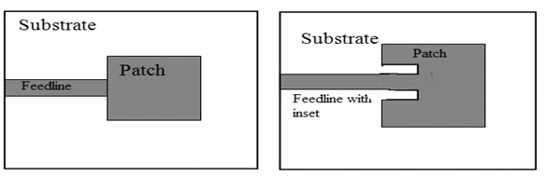

**Figure:2.4.1 Microstrip Line Feed**

**2.4.2 Coaxial Feed**

The coaxial feed or probe feed is a very common technique used for feeding Microstrip patch antennas. As seen from Figure 2.4.2, the inner conductor of the coaxial connector extends through the dielectric and is soldered to the radiating patch, while the outer conductor is connected to the ground plane. The main advantage of this type of feeding scheme is that the feed can be place at any desired location inside the patch in order to match with its input impedance. This feed method is easy to fabricate and has low spurious radiation. However, its major disadvantage is that it provides narrow bandwidth and is difficult to model since a hole has to be drilled in the substrate and the connector protrudes outside the ground plane, thus not making it completely planar for thick substrates (h > 0.02λ0). Also, for thicker substrates, the increased probe length makes the input impedance more inductive, leading to matching problems. It is seen above that for a thick dielectric substrate, which provides broad bandwidth, the microstrip line feed and the coaxial feed suffer from numerous disadvantages. The non-contacting feed techniques discussed below, solve these problems.

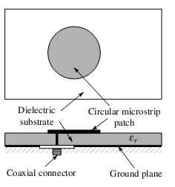

**Figure:2.4.2 Coaxial Feed**

**2.4.3 Aperture Coupled Feed**

In this type of feed technique , the radiating patch and the microstrip feed line are separated by the ground plane shown in Figure 2.4.3. Coupling between the patch and the feed line is made through a slot or an aperture in the ground plane.

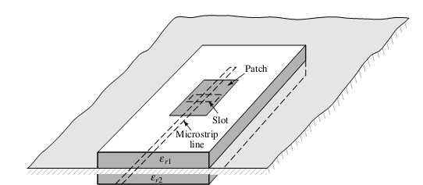

**Figure:2.4.3 Aperture Feed**

The coupling aperture is usually centered under the patch, leading to lower cross polarization due to symmetry of the configuration. The amount of coupling from the feed line to the patch is determined by the shape, size and location of the aperture. Since the ground plane separates the patch and the feed line, spurious radiation is minimized. Generally, a high dielectric material is used for the bottom

Substrate and a thick, low dielectric constant material is used for the top substrate to optimize radiation from the patch. The major disadvantage of this feed technique is that it is difficult to fabricate due to multiple layers, which also increases the antenna thickness. This feeding scheme also provides narrow bandwidth.

**2.4.4 Proximity Coupled Feed**

This type of feed technique is also called as the electromagnetic coupling scheme. As shown in Figure 2.4.4, two dielectric substrates are used such that the feed line is between the two substrates and the radiating patch is on top of the upper substrate. The main advantage of this feed technique is that it eliminates spurious feed radiation and provides very high bandwidth (as high as 13%), due to overall increase in the thickness of the microstrip patch antenna. This scheme also provides choices between two different dielectric media, one for the patch and one for the feed line to optimize the individual performances.

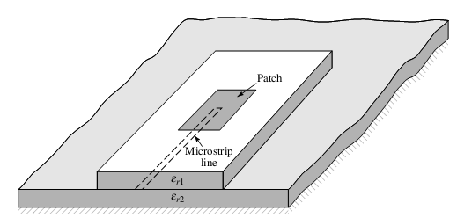

**Figure:2.4.4 Proximity Coupled Feed**

Matching can be achieved by controlling the length of the feed line and the width-to-line ratio of the patch. The major disadvantage of this feed scheme is that it is difficult to fabricate because of the two dielectric layers which need proper alignment. Also, there is an increase in the overall thickness of the antenna.

It uses a two-layer substrate with a microstrip line on the lower substrate, terminating in an open stub below the patch which is printed on the upper substrate. It is a type of non- contacting feed. Proximity coupling has the advantage of allowing the patch to exist on a relatively thick substrate for improved bandwidth; on the contrary the feed line is on an effectively thin substrate, which reduces spurious radiation and coupling.

**Table.2.4.5 Comparison of different Feed Method**

|  |  |  |  |  |  |
| --- | --- | --- | --- | --- | --- |
| **Characteristics** | **Microstrip Feed line** | **Coaxial Feed** | **Aperture coupling Feed** | **Proximity Feed** | **Coplanar Waveguide** |
| **Spurious Feed Radiation** | More | More | More | More | More |
| **Reliability** | Better | Poor due to soldering | Good | Good | Good |
| **Impedance Matching** | Easy | Easy | Easy | Easy | Easy |
| **Bandwidth** | 2-5% | 2-5% | 13% | 21% | 40% |

Table:2.4.5 Summarizes the characteristics of the different feed techniques.

It is to be noted that in our project simulations we have used microstrip feed line techniques.

**2.5 METHODS OF ANALYSIS**

The most popular models for the analysis of Microstrip patch antennas are the transmission line model, cavity model, and full wave model (which include primarily integral equations/Moment Method). The transmission line model is the simplest of all and it gives good physical insight but it is less accurate. The cavity model is more accurate and gives physical insight but is complex in nature. The full wave models are extremely accurate, versatile and can treat single elements, finite and infinite arrays, stacked elements, arbitrary shaped elements and coupling.

It must be noted that our project is centered on the transmission line model and uses all of the empirical equations this model is based on for simulations. The cavity model is not at the center of our project and is hence explained very briefly. The method of moments is explained in detail as it is used by several field solvers (such as IE3D) for simulations.

**2.5.1 Transmission Line Model**

This model represents the microstrip antenna by two slots of width W and height h, separated by a transmission line of length L. The microstrip is essentially a non homogenous line of two dielectrics, typically the substrate and air. Figure 3.8 illustrates this

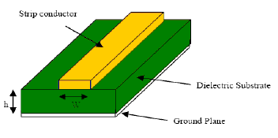

**Figure:2.5.1 Microstrip patch line**

As seen from Figure 2.5.1, most of the electric field lines reside in the substrate and parts of some lines in air. As a result, this transmission line cannot support pure transverse electric-magnetic (TEM) mode of transmission, since the phase velocities would be different in the air and the substrate.

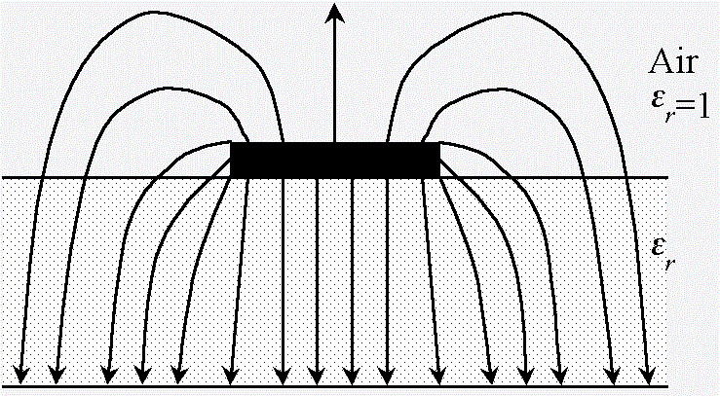

**Figure:2.5.2 electric Field Line**

Instead, the dominant mode of propagation would be the quasi-TEM mode. Hence, an effective dielectric constant (εreff) must be obtained in order to account for the fringing and the wave propagation in the line. The value of εreff is slightly less then εr because the fringing fields around the periphery of the patch are not confined in the dielectric substrate but are also spread in the air as shown in Figure 2.5.2. The expression for εreff is given as:

Εreff= (2.1)

Where,

εreff=Effective dielectric constant

εr=Dielectric constant of substrate

h=Height of dielectric substrate

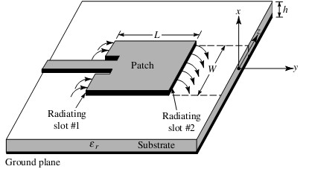W=Width of the patch

**Figure:2.5.3 Microstrip patch Antenna**

Figure 2.5.3 shows a rectangular microstrip patch antenna of length L, width W resting on a substrate oh height h. The co-ordinate axis is selected such that the length is along the x direction, width is along the y direction and the height is along the z direction. In order to operate in the fundamental TM mode, the length of the patch must be slightly less than where is the wavelength in the dielectric medium and is equal to 0/ reff) where 0 is the free space wavelength. The TM mode implies that the field varies one /2 cycle along the length, and there is no variation along the width of the patch. In figure 3.11 the microstrip patch antenna is represented by two slots, separated by a transmission line of length L and open circuited at both the ends. Along the width of the patch, the voltage is maximum and current is minimum due to the open ends. The fields at the edges can be resolved into normal and tangential components with respect to the ground plane.

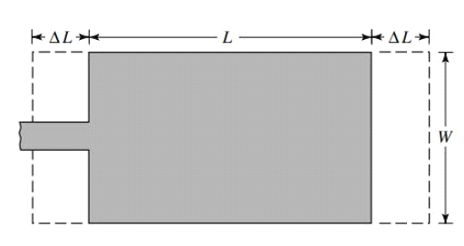

**Figure:2.5.4 Top view of Antenna**

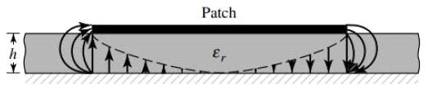It is seen from figure 2.5.4 that the normal components of the electric field at the two edges along the width are in opposite directions and thus out of phase since the patch is /2 long and hence they cancel each other in the broadside direction. The tangential components, which are in phase, means that the resulting fields combine to give maximum radiated field normal to the surface of the structure. Hence the edges along the width can be represented as two radiating slots, which are /2 apart and excited in phase and radiating in the half space above the ground plane.

**Figure:2.5.5 Side View of Antenna**

The fringing fields along the width can be modeled as radiating slots and electrically the patch of the microstrip antenna looks greater than its physical dimensions.

**2.5.2 Cavity Model**

Although the transmission line model discussed in the previous section easy to use, it has some inherent disadvantages. Specifically, it is useful for patches of rectangular design and it ignores field variations along the radiating edges. These disadvantages can be overcome by using the cavity model. In this model, the interior region of the dielectric substrate is modeled as a cavity bounded by electric walls on the top and bottom. The basis for this assumption is the following observations for thin substrates (h<<λ).

* Since the substrate is thin, the fields in the interior region do not vary much in the z direction, i.e. normal to patch.
* The electric field is z directed only, and the magnetic field has only the transverse components Hx and Hy in the region bounded by the patch metallization and the ground plane. This observation provides for the electric walls at the top and the bottom.

**2.6 PERFORMANCE PARAMETERS**

The performance of an antenna can be measured by a number of parameters. The following are the critical ones,

**2.6.1 Radiation pattern**

The antenna pattern is a graphical representation in three dimensional of the radiation of the antenna as the function of direction. It is a plot of the power radiated from an antenna per unit slid angle which gives the intensity of radiations from the antenna. If the total power radiated by the isotropic antenna is P, then the power is spread over a sphere of radius r, so that power density S at this distance in any direction is given as,

(2.7)

Then the radiation intensity for this isotropic antenna *Ui* can be written as,

(2.8)

Isotropic antennas are not realizable in practice but can be used as a reference to compare the performance of practical antennas. The radiation pattern provides information on the antenna beam width, side lobes and antenna resolution to a large extent.

The E plane pattern is a graphical representation of antenna radiation as a function of direction in a plane containing a radius vector from the center of the antenna to the point of maximum radiation and the electric field intensity vector. Similarly the H plane can be drawn considering the magnetic field intensity vector.

**2.6.2 Gain**

Antenna gain the ratio of maximum radiation intensity at the peak of main beam to the radiation intensity in the same direction which would be produced by an isotropic radiator having the same input power. Isotropic antenna is considered to have a gain of unity.

Where G() is the power radiated per unit solid angle in the direction P() and Wt is the total radiated power. Microstrip antennas because of the poor radiation efficiency poor gain. Numerous researches have been conducted in various parts of the world in order to obtain high gain antennas.

**2.6.3 Directivity**

If a three dimensional antenna patter is measured , the ratio of normalized power density at the peak of the main beam to the average power density is called the directivity

**2.6.4 Bandwidth**

It is defined as “The range of usable frequencies within which the performance of the antenna, with respect to some characteristics, conforms to a specified standard”. The bandwidth can be the range of frequencies on either side of the centre frequency where the antenna characteristics like input impedance, radiation pattern, beam width, polarization, side lobe level or gain, are close to those values which have been obtained at the centre frequency.

**2.6.5 Effective area or aperture**

The effective area or effective aperture of a receiving antenna expresses the portion of the power of a passing electromagnetic wave which it delivers to its terminals, expressed in terms of an equivalent area. Since the receiving antenna is not equally sensitive to signals received from all directions, the effective area is the function of the direction to the source. Due to reciprocity (discussed above) the gain of an antenna used for transmitting must be proportional to its effective area when used for receiving. Consider an antenna with no loss, that is, one whose electrical efficiency is 100%. It can be shown that its effective area averaged over all directions must be equal to2/4π, the wavelength squared divided by 4π. Gain is defined such that the average gain over all directions for an antenna with 100% electrical efficiency is equal to 1.

For an antenna efficiency with an of less than 100%, both the effective area and gain are reduced by that same amount. Therefore the above relationship between gain and effective area still holds. These are thus two different ways of expressing the same quantity. Aeff is especially convenient when computing the power that would be received by an antenna of a specified gain.

**2.6.6 Efficiency**

Efficiency of a transmitting antenna is the ratio of power actually radiated (in all directions) to the power absorbed by the antenna terminals. The power supplied to the antenna terminals which is not radiated is converted into heat. This is usually through loss resistance in the antenna’s conductors, but can also be due to dielectric or magnetic core losses in antennas(or antenna systems) using such components. Such loss effectively robs power from the transmitter, requiring a stronger transmitter in order to transmit a signal of a given strength.

**2.6.7 Polarization**

The polarization of an antenna refers to the orientation of the electric field (E plane) of the radio wave with respect to the Earth’s surface and is determined by the physical structure of the antenna and by its orientation; note that this designation is totally distinct from the antenna’s directionality. Thus, a simple straight wire antenna will have one polarization when mounted vertically, and a different polarization when mounted horizontally. As a transverse wave, the magnetic field of a radio wave is at right angles to that of the electric field, but by convention, talk of an antenna’s “polarization” is understood to refer to the direction of the electric field.

Reflections generally affect polarization. For radio waves, one important reflector is the ionosphere which can change the wave’s polarization. Thus for signals received following reflection by the ionosphere (a sky wave), a consistent polarization cannot be expected. For line of sight communication or ground wave propagation, horizontally or vertically polarized transmissions generally remain in the about the same polarization state at the receiving location. Matching the receiving antenna’s polarization to that of the transmitter can make a very substantial difference in received signal strength.

Polarization is predictable from an antenna’s geometry, although in some cases it is not at all obvious. An antenna’s linear polarization is generally along the direction(as viewed from the receiving location) of the antenna’s currents when such a direction can be defined. For instance, a vertical or Wi-Fi antenna vertically oriented will transmit and receive in the vertical polarization. Antennas with horizontal elements, such as most roof top TV antennas, are horizontally polarized (broadcast TV usually uses horizontal polarization). Even when the antenna system has a vertical orientation , such as an array of horizontal dipole antennas, the polarization is in the horizontal direction corresponding to the current flow. The polarization of a commercial antenna is an essential specification.

Polarization is the sum of the E-plane orientations over time projected onto an imaginary plane perpendicular to the direction of motion of the radio wave. In the most general case, polarization is elliptical, meaning that the polarization of the radio waves varies over time. Two special cases are linear polarization (the ellipse collapse into a line) as we have discussed above, and circular polarization (in which the two axes of the ellipse are equal). In linear polarization the electric field of the radio wave oscillates back and forth along one direction; this can be affected by the mounting of the antenna but usually the desired direction is either horizontal or vertical polarization. In circular polarization, the electric field and magnetic field of the radio waves rotates at the radio frequency circularly around the axis of propagation. Circular or elliptically polarized radio waves are designated as right handed rule from the one used by radio engineers.

It is the best for the receiving antenna to match the polarization of the transmitted wave for optimum reception. Intermediate matching will lose some signal strength, but not as much as a complete mismatch. A circularly polarized antenna can be used to equally well match vertical or horizontal linear polarizations. Transmission from a circularly polarized antenna received by a linearly polarized antenna (or vice versa) entails a 3dB reduction in signal to noise ratio as the received power has there by been cut in half.

**2.6.8 Impedance matching**

Maximum power transfer requires matching the impedance of an antenna system(as seen looking into transmission line) to the complex conjugate of the impedance of the receiver or transmitter. In the case of a transmitter, however, the desire matching impedance might not correspond to the dynamic output impedance of the transmitter as analyzed as a source impedance but rather the design value (typically 50 ohms) required for efficient and safe operation of the transmitting circuitry. The intended impedance is normally resistive but transmitter (and some receivers) may have additional adjustments to cancel a certain amount of reactance in order to “tweak” the match. When the transmission line is used in between the antenna and the transmitter(or receiver) one generally would like an antenna system whose impedance is resistive and near the characteristic impedance of that transmission line in order to minimize the standing wave ratio (SWR) and the increase in transmission line losses it entails, in addition to supplying a good match at the transmitter or receiver itself. In some cases this is done in a more extreme manner, not simply to cancel a small amount of residual reactance, but to resonate an antenna whose resonance frequency is quite different than the intended frequency of operation. For instance, a “whip antenna” can be made significantly shorter than ¼ wavelength long, for practical reasons, and then resonated using a so-called loading coil. This physically large inductor at the base of the antenna has an inductive reactance which is the opposite of the capacitive reactance that such a vertical antenna has at the desired operating frequency. The result is pure resistance seen at the feed point of the loading coil; unfortunately that resistance is some what lower than would be desired to match commercial.

So an antenna tuning generally refers to cancellation of any reactance seen at the antenna terminals, leaving only a resistive impedance which might or might not be exactly the desired impedance (that of the transmission line). Although an antenna may be designed to have a purely resistive feed point impedance (such as a dipole 97% of a half wavelength long) this might not be exactly true at the frequency that it is eventually used at. In some cases the physical length of the antenna can be “trimmed” to obtain a pure resistance. On the other hand, the addition of a series inductance or parallel capacitance can be used to cancel a residual capacitive or inductive reactance, respectively.

**2.6.9 Return loss**

Return loss or reflection loss is the reflection of signal power from the insertion of a device in a transmission line or optical fiber. It is expressed as ratio in dB relative to the transmitted signal power.

**2.6.10 VSWR**

A standing wave in a transmission line is a wave in which the distribution of current, voltage or field strength is formed by the superimposition of two waves of same frequency propagating in opposite direction. Then the voltage along the line produces a series of nodes and antinodes at fixed positions.

**CHAPTER 3**

**RESULTS AND DISCUSSIONS**

**3.1 INTRODUCTION**

In this chapter, the procedure for designing a microstrip patch antenna for multiband application is explained. Next, a compact microstrip patch antenna is defined for use in multiband wireless applications. Finally the results obtained from the simulations are demonstrated.

**3.2 DESIGN SPECIFICATIONS**

The three essential parameters for the design of a slotted microstrip patch are given below.

Frequency of operation(f0): The resonant frequency of the antenna must be selected appropriately. For multiband operation the frequency range selected is from 0-10 GHz. Hence the antenna designed must be able to operate in this high frequency range. The resonant frequency selected for my design are 2.7GHz.

Dielectric constant of the substrate(𝞮r): The dielectric material selected for our design is ‘Air’ which has a dielectric constant of 1.00059. A substrate with a low dielectric constant has been selected. Since it increased the bandwidth of the antenna.

Height of dielectric substrate(h): For the microstrip patch antenna to be used in multiband applications, it is essential that the antenna is not bulky. Hence, the essential parameters for the design are

Frequency of operation (f0)= 2.7 GHz.

Dielectric constant of the substrate(𝞮r)= 2.2

**Figure:3.1 PROPOSED ANTENNA GEOMETRY**

Figure 3.1 shows the proposed antenna which indicates the radiator fed with microstrip feed line. The radiator consists of slot along with the feed in the in the radiating edge. These slot with the feed reduce the return loss to a greater extent.

The dimensions for the iterations are given as,

*a* =length of the patch

*b* =width of the patch

*c*= length of the patch

*d*= length of the patch

*e*= length of the patch

The proposed antenna is designed by cutting single patch to make it a patch antenna. Cutting of patches in antenna increases the current path which increases the current intensity, as a result efficiency is increased. The basic structure of antenna consists of ground plane, substrate, patch and feed line. The transmission line is the preferred method of analysis for calculating the various dimensions of the microstrip patch antenna.

The transmission line model is applicable to infinite ground planes only. However, for practical considerations it is essential to have a finite round plane. It has been shown by that similar results for finite and infinite ground plane can be obtained if the size of the ground plane is greater the patch dimensions by approximately six times the substrate thickness all-round the periphery

**3.3 SIMULATION RESULTS**

The software used to model and simulate the microstrip patch antenna in CST is a high performance full wave electromagnetic (EM) field simulator for arbitrary 3D volumetric passive device modelling that takes advantages of the familiar micro soft graphical user interface.

CST can be used to calculate parameters such as S-parameters, Resonant frequency and Fields. HFSS is a full-wave electromagnetic simulator based on the method of moments. It analyzes 3D and multilayer structures of general shapes. CST pioneered the use of the Finite Element Method(FEM) for EM simulation by developing or implementing technologies such as tangential vector finite elements, adaptive meshing and Adaptive Lancozos Pade Sweep(ALPS).

It has been widely used in the design of RFICs, patch antennas, wire antennas and other RF or wireless antennas. It has been used to calculate and plot the S11 parameters, VSWR, current distributions as well as the radiation pattern

**Figure:3.3 Return loss**

Return loss or reflection loss is the loss of signal power resulting from the reflection cost at a discontinuity in a transmission line or optical fiber.

Figure3.3 shows the proposed microstrip patch antenna with slot using microstrip feed line as a feeding technique, which gives the return loss or reflection coefficient value as -37 dB in the frequency range of 2.55 GHz.

The transmission feed used in design to have a frequency range of 2.7 GHz is selected and frequency points are selected over this range to obtain accurate results.

The most common case for measuring and examining VSWR is when installing and tuning transmitting antennas. When a transmitter is connected to an antenna by a feed line, the impedance of the antenna and feed line must match exactly for maximum energy transfer from the feed line to the antenna to be possible.

Figure 3.4 shows that the desirable VSWR (<2) is achieved in the frequency range 0 to 10 GHz.

Graphical representation of the spatial distribution of the radiation from an antenna is represented as a function of angle. The proposed antenna is showing Bi directional pattern.

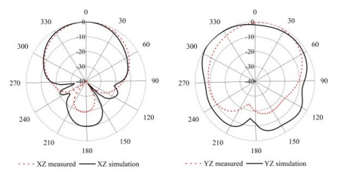

**Figure:3.5 2D Radiation Pattern**

The radiation field of the microstrip patch antenna is shown in figure 3.5 which is determine using either an “electric current model” or a “magnetic current model”. In the electric current model, the current in is used directly to find the far field radiation pattern.

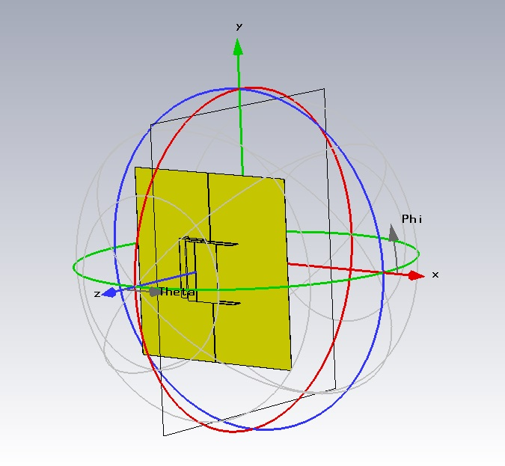

**Figure:3.6 3D Radiation Pattern**

The radiation field of the microstrip patch antenna is shown in figure 3.6 which is determine using either an “electric current model” or a “magnetic current model”. In the electric current model, the current in is used directly to find the far field radiation pattern.

If the substrate is neglected (replaced by air) for the calculation of the radiation pattern, the pattern may be found directly from image theory. If the substrate is accounted for and is assumed infinite, the reciprocity method may be used to determine the far-field pattern.

**Skull without tumor modelling:**

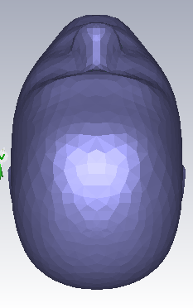

**Skull with tumour modelled:**

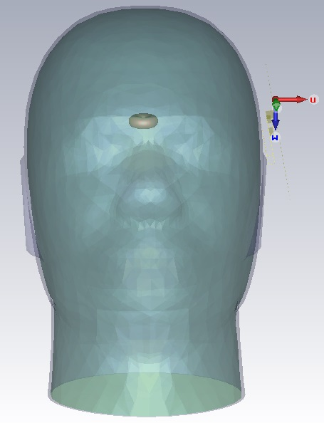

It can be shown that the electric and magnetic current models yield exactly the same results for the far-field pattern, provide the pattern of each current is calculated in the presence of the substrate at the resonant frequency of the patch cavity model. Figure 3.6 shows that at 2.7 GHz a graphical representation in polar coordinates of spatial distributions of fabricated antenna is shown.

**3.4 Discussions**

In every antenna design, simulation is always an important step. All the study of parameter can be predicted before it is to make changes.

Simulation is done using CST. All of the shapes shown in this section are simulated. The simulated results are compared. The results investigated in this section for the design are return loss, VSWR and radiation pattern. By varying these widths of the slot, length of the slot, feed and feed position of S-parameter variation is studied for the slotted patch antenna.

The characteristics of proposed antennas have been investigated through different parametric studies using CST simulation software. The proposed antenna have achieved stable radiation pattern and satisfied return loss. This antenna design can be used for multiband applications.

**SOFTWARE DESCRIPTION**

**CST SOFTWARE:**

The antenna is designed and simulated in CST (Computer simulation technology) design software. CST is a commercial finite element method solver for electromagnetic structures. The acronym originally stood for high frequency structural simulator. It is one of several commercial tools used for antenna design, and the design of complex RF electronic circuit elements including filters, transmission lines, and packaging.CST offers accurate, efficient computational solutions for electromagnetic design and analysis. Our 3D EM simulation software is user friendly and enables you to choose the most appropriate method for the design and optimization of devices operating in a wide range of frequencies. It is based on Finite Element Method (FEM).

FEM has its origin in the field of structural analysis. It is a more powerful and adaptable numerical technique for handling programs involving complex 24 geometries. In mathematics, FEM is a numerical technique for finding approximate solutions to boundary value problems. It uses variation methods (the Calculus of variations) to decrease an error function and produce a steady solution. As we know that joining many tiny straight lines can approximate a larger circle, FEM involves all the methods for connecting many simple element equations over many small subdomains, named finite elements, to approximate a more complex equation over a larger domain. FEM analysis of any problem involves basically four steps Passive microwave and RF component design is a major application of CST and supporting it is one of CST ’s core competencies. CST MWS offers a broad range of solver technologies, operating in both the time and frequency domain and capable of using surface meshes as well as Cartesian and tetrahedral volume meshes. An antenna array allows us to achieve high gain with multiple radiating elements and a phased array in addition offers the possibility to shape and steer the beam without changing the array geometry.

**5.3 DESIGN PROCEDURE FOR THE SIMULATION:**

There are six main steps to create and solve a proper CST simulation. They are

1. Create model/geometry

2. Assign boundaries

3. Assign excitations

4. Setup the solution

5. Solve

6. Post process the results

SOFTWARE DESCRIPTION:

In Brief

The adaptive solution process is the method by which CST guarantees that a final answer to a given EM problem is the correct answer. It is a necessary part of the overall solution process and is the key reason why a user can have extreme confidence in CST ’s accuracy.

PROCESS FLOW DIAGRAM:

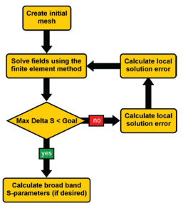

In Detail

The adaptive analysis is a solution process in which the mesh is refined iteratively. Refinement of the mesh is localized to regions where the electric field solution error is high. This adaptive refinement increases the solution’s accuracy with each adaptive solution. The user sets the criteria that control mesh refinement during an adaptive field solution. Most CST problems can only be accurately solved by using the adaptive refinement process.

Work flow of CST:

There are six main steps to creating and solving a proper CST simulation.

They are:

1. Create model/geometry

2. Assign boundaries

3. Assign excitations

4. Set up the solution

5. Solve

6. Post-process the results

FLOW DESIGN:

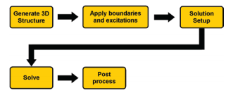

In Detail

Every CST simulation will involve, to some degree, all six of the above steps. While it is not necessary to follow these steps in exact order, it is good modeling practice to follow them in a consistent model-to-model manner.

Step One:

The initial task in creating an CST model consists of the creation of the physical model that a user wishes to analyze. This model creation can be done within CST using the 3D modeler. The 3D modeler is fully parametric and will allow a user to create a structure that is variable with regard to geometric dimensions and material properties. A parametric structure, therefore, is very useful when final dimensions are not known or design is to be “tuned.” Alternatively, a user can import 3D structures from mechanical drawing packages, such as SolidWorks®, Pro/E® or AutoCAD®. However, imported structures do not retain any “history” of how they were created, so they will not be parameterizable upon import. If parameterization of the structure is desired, a user will need to manually modify the imported geometry so that parameterization is possible.

Step Two:

The assignment of “boundaries” generally is done next. Boundaries are applied to specifically created 2D (sheet) objects or specific surfaces of 3D objects. Boundaries have a direct impact on the solutions that CST provides; therefore, users are encouraged to closely review the section on Boundaries in this document.

Step Three:

After the boundaries have been assigned, the excitations (or ports) should be applied. As with boundaries, the excitations have a direct impact on the quality of the results that CST will yield for a given model. Because of this, users are again encouraged to closely review the section on excitations in this document. While the proper creation and use of excitations is important to obtaining the most accurate CST results, there are several convenient rules of thumb that a user can follow. These rules are described in the excitations section.

Step Four:

Once boundaries and excitations have been created, the next step is to create a solution setup. During this step, a user will select a solution frequency, the desired convergence criteria, the maximum number of adaptive steps to perform, a frequency band over which solutions are desired, and what particular solution and frequency sweep methodology to use.

Step Five:

When the initial four steps have been completed by an CST user, the model is now ready to be analyzed. The time required for an analysis is highly dependent upon the model geometry, the solution frequency, and available computer resources. A solution can take from a few seconds, to the time needed to get a coffee, to an overnight run. It is often beneficial to use the remote solve capability of CST to send a particular simulation run to another computer that is local to the user’s site. This will free up the user’s PC so it can be used to perform other work.

Step Six:

Once the solution has finished, a user can post-process the results. Post processing of results can be as simple as examining the S-parameters of the device modelled or plotting the fields in and around the structure. Users can also examine the far fields created by an antenna. In essence, any field quantity or S, Y, Z parameter can be plotted in the post-processor. Additionally, if a parameterized model has been analyzed, families of curves can be created.

3D modelling:

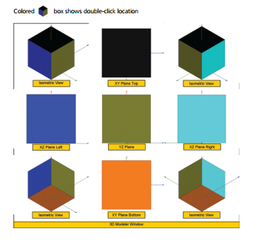

Hotkeys are specific keys or a combination of keys that have a specific purpose. The most

Common hot keys are for pan, rotate, and zoom. Additionally, hotkeys can be used to produce planar XY, YZ, XZ, and the standard isometric views of objects in the modeling window.

SHIFT + Left Mouse Button: Drag

Alt + Left Mouse Button: Rotate model

Alt + SHIFT + Left Mouse Button: Zoom in

Boundaries:

The Available boundaries within CST

In Brief

There are twelve boundaries available within CST. Boundaries are applied to specifically create 2D sheet objects, or surfaces of 3D objects. The twelve boundaries are:

1. Perfect Electric Conductor (PEC): default CST boundary fully encloses the solution Space and creates a closed model

2. Radiation: used to create an open model

3. Perfectly Matched layer (PML): used to create an open model and preferred for antenna simulations

4. Finite Conductivity: allows creation of single layer conductors

5. Layered Impedance: allows creation of multilayer conductors and thin dielectrics

6. Impedance: allows creation of ohm per square material layers

7. Lumped RLC: allows creation of ideal lumped components

8. Symmetry: used to enforce a symmetry boundary

9. Master: used in conjunction with Slave Boundary to model infinitely large repeating array structures

10. Slave: used in conjunction with Master Boundary to model large infinitely repeating array structures

11. Screening Impedance: allows creation of large screens or grids

12. Perfect H: allows creation of a symmetry plane

EXCITATION:

A Wave Port is the most commonly used type of excitation used in CST . This port type is very useful for exciting micro strip, stripline, coaxial, or waveguide transmission lines. It should be applied only to an outer face of the solution space.co axial based feeding and dielectric resonator based feeding has been analysed below here.

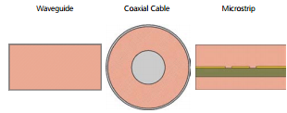

Excitations Lumped Ports:

Lumped Ports are the other commonly used excitation type in CST . This port type is analogous to a current sheet source and can also be used to excite commonly used transmission lines. Lumped ports are also useful to excite voltage gaps or other instances where wave ports are not applicable. They should only be applied internally to the solution space. Shown below are examples of commonly used wave ports with proper size dimensions.

Lumped port shown below:

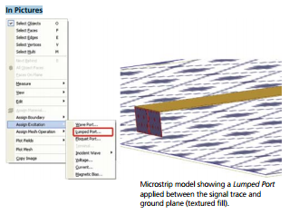

PORT REFINEMENT AND ANALYSIS:

The maximum Refinement Per Pass and maximum number of Passes Settings

The Maximum number of passes is the maximum number of adaptive iterations CST performs in order to reach convergence. The Maximum refinement per pass is the percentage of tetrahedral elements that are subdivided with each adaptive pass

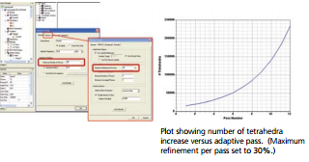

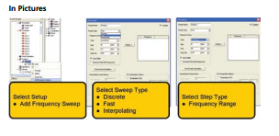

PROCESS FLOW DIAGRAM:

ASSIGNING BOUNDARIES IN THE GUI

Boundaries are assigned to specifically created 2D object in an CST model or to specific faces of 3D objects.

In Pictures

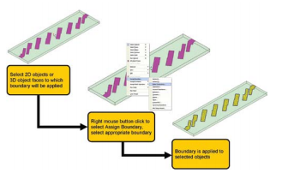

To assign a boundary to a 2D object or 3D face, simply change to the select faces mode and select the appropriate 2D object or 3D face. If a common boundary is to be applied to multiple faces, the multiple faces can be selected by holding the CTRL key. Once all the desired faces have been selected, simply perform a right mouse button click and select Assign Boundary. Finally, select the desired boundary. Alternatively, once all the faces have been selected, a user can click on CST in the top-level menu bar, select boundaries, choose assign, and select the desired boundary.

Assigning driven modal Solution excitations in the GUI:

Excitations are assigned to specifically create 2D object in an CST model or to specific faces of 3D objects. The solution type selected dictates the steps a user needs to follow in order to create a port excitation. Shown Below are the steps for a driven modal solution.

In Pictures

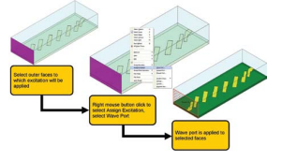

To assign an excitation to a 2D object or 3D face, simply change to the select faces mode and select the appropriate 2D object or 3D face. Multiple faces can be selected if a common excitation is to be applied to them. Once all the desired faces have been selected, simply perform a right mouse button click, select assign excitations, and choose the desired excitation. Alternatively, once all the faces have been selected, a user can click on CST in the top-level menu bar, select excitations, choose assign, and select the desired excitation.

A user should ensure that the port area is of the proper dimension. For reference, see the section on ports. While it is not necessary to create an integration line when creating a wave port, it is good modelling practice and is, therefore, strongly, encouraged.

**HARDWARE DESCRIPTION:**

**MATERIAL USED: ‘**COPPER’

Copper is an excellent electrical [conductor](javascript:showGloss(%22cond%22)). Most of its uses are based on this property or the fact that it is also a good thermal conductor. However, many of its applications also rely on one or more of its other properties. For example, it wouldn't make very good water and gas pipes if it were highly [reactive](javascript:showGloss(%22reac%22)). On this page, we look at these other properties:

* [**a good electrical conductor**](http://resources.schoolscience.co.uk/CDA/14-16/chemistry/copch0pg3.html#elec)
* [**a good thermal conductor**](http://resources.schoolscience.co.uk/CDA/14-16/chemistry/copch0pg4.html)
* [**corrosion resistant**](http://resources.schoolscience.co.uk/CDA/14-16/chemistry/copch0pg5.html#reac)
* [**antibacterial**](http://resources.schoolscience.co.uk/CDA/14-16/chemistry/copch0pg5.html#anti)
* [**easily joined**](http://resources.schoolscience.co.uk/CDA/14-16/chemistry/copch0pg5.html#easi)
* [**ductile**](http://resources.schoolscience.co.uk/CDA/14-16/chemistry/copch0pg5.html#duct)
* [**tough**](http://resources.schoolscience.co.uk/CDA/14-16/chemistry/copch0pg5.html#toug)
* [**non magnetic**](http://resources.schoolscience.co.uk/CDA/14-16/chemistry/copch0pg5.html#nonm)
* [**attractive colour**](http://resources.schoolscience.co.uk/CDA/14-16/chemistry/copch0pg5.html#attr)
* [**easy to alloy**](http://resources.schoolscience.co.uk/CDA/14-16/chemistry/copch0pg5.html#allo)
* [**recyclable**](http://resources.schoolscience.co.uk/CDA/14-16/chemistry/copch0pg5.html#recy)
* [**catalytic**](http://resources.schoolscience.co.uk/CDA/14-16/chemistry/copch0pg5.html#cata)

**Corrosion resistant**

* Copper is low in the [reactivity series](javascript:showGloss(%22reacs%22)). This means that it doesn't tend to corrode. Again, this is important for its use for pipes, electrical cables, saucepans and radiators.
* However, it also means that it is well suited to decorative use. Jewellery, statues and parts of buildings can be made from copper, [brass](javascript:showGloss(%22bras%22)) or [bronze](javascript:showGloss(%22bron%22)) and remain attractive for thousands of years.

**Antibacterial**

* Copper is a naturally hygienic metal that slows down the growth of germs such as E-coli (the “burger bug”), MRSA (the hospital “superbug”) and legionella.
* This is important for applications such as food preparation, hospitals, coins (see [**biocidal copper**](http://resources.schoolscience.co.uk/3/biology/copper/copch31pg2.html)), door knobs and plumbing systems.

**Easily joined**

* Copper can be joined easily by [soldering](javascript:showGloss(%22sold%22)) or [brazing](javascript:showGloss(%22braz%22)). This is useful for pipework and for making sealed copper vessel.

**SUBSTRATE:** AIR

**TEFLON:**

It is used as an insulating material in Feed line.

**Properties:**

Chemical Properties:

* Chemical resistance to corrosive reagents
* Nonsolubility
* Long-term weatherability
* Nonadhesiveness
* Nonflammability

Electrical Properties:

* Low dielectric constant
* Low dissipation factor
* High arc-resistance
* High surface resistivity
* High volume resistivity

Mechanical Properties:

* Flexibility at low temperatures
* Low coefficient of friction
* Stability at high temperatures

**CHAPTER 4**

**CONCLUSION AND FUTURE WORK**

**4.1 CONCLUSION**

A patch antenna in the radiator and partial ground plane has been designed and simulated. The proposed antenna exhibits five bands, it supports for 2.55 GHz, as well as good radiation properties. Therefore this antenna suitable for Super High Frequency application are other biomedical applications that works in these frequencies. Patch antenna for single band frequency applications with SISO technique is simulated.

**4.2 FUTURE WORK**

* To compare return loss and VSWR value of a microstrip patch antenna with microstrip feed line technique and microstrip patch antenna with coaxial feed line results at a frequency range of 2 to 4 GHz.
* To analyze and design this microstrip patch antenna with any shape in the partial ground plane by using microstrip feeding method.
* Results of studies have also been used to propose a methodology to design other frequency bands.

**REFERENCES**

[1] B. J. Mohammed, A. M. Abbosh, S. Mustafa, and D. Ireland, "Microwave  
system for head imaging," *Instrumentation and Measurement, IEEE  
Transactions on,* vol. 63, pp. 117-123, 2014.

[2] o. N.-I. R. H. IEEE Standards Coordinating Committee 28, *IEEE Standard  
for Safety Levels with Respect to Human Exposure to Radio Frequency  
Electromagnetic Fields, 3kHz to 300 GHz*: Institute of Electrical and Electonics  
Engineers, Incorporated, 1992.

[3] A. Sabouni and A. Kishk, "Dual-polarized, broadside, thin dielectric  
resonator antenna for microwave imaging," *Antennas and Wireless  
Propagation Letters, IEEE,* vol. 12, pp. 380-383, 2013.

[4] A. T. Mobashsher, A. M. Abbosh, and Y. Wang, "Microwave system to  
detect traumatic brain injuries using compact unidirectional antenna and  
wideband transceiver with verification on realistic head phantom," *Microwave  
Theory and Techniques, IEEE Transactions on,* vol. 62, pp. 1826-1836, 2014.

[5] X. Li, M. Jalilvand, Y. L. Sit, and T. Zwick, "A compact double-layer onbody matched bowtie antenna for medical diagnosis," *Antennas and  
Propagation, IEEE Transactions on,* vol. 62, pp. 1808-1816, 2014.

[6] A. T. Mobashsher and A. Abbosh, "Slot-loaded folded dipole antenna with  
wideband and unidirectional performance for L-band applications," *Antennas  
and Wireless Propagation Letters, IEEE,* vol. 13, pp. 798-801, 2014.

[7] S. Ahdi Rezaeieh and A. Zamani, "3-D Wideband Antenna for HeadImaging System with Performance Verification in Brain Tumor Detection,"  
*Antennas and Wireless Propagation Letters, IEEE,* vol. 14, pp. 910-914, 2015.

[8] C. Chiu, H. Wong, and C. Chan, "Study of small wideband folded-patchfeed antennas," *IET Microwaves, Antennas & Propagation,* vol. 1, pp. 501-505,  
2007.

[9] T. Taga and K. Tsunekawa, "Performance Analysis of a Built-In Planar  
Inverted F Antenna for 800 MHz Band Portable Radio Units," *IEEE Journal on  
Selected Areas in Communications,* vol. 5, pp. 921-929, 1987.

[10] W.-L. Chen, G.-M. Wang, and C.-X. Zhang, "Bandwidth enhancement  
of a microstrip-line-fed printed wide-slot antenna with a fractal-shaped slot,"  
*Antennas and Propagation, IEEE Transactions on,* vol. 57, pp. 2176-2179,  
2009.

[11] S. Ahdi Rezaeieh, A. Abbosh, and Y. Wang, "Wideband unidirectional  
antenna of folded structure in microwave system for early detection of  
congestive heart failure," *Antennas and Propagation, IEEE Transactions on,*vol. 62, pp. 5375-5381, 2014.

[12] C. M. Kruesi, R. J. Vyas, and M. M. Tentzeris, "Design and development  
of a novel 3-D cubic antenna for wireless sensor networks (WSNs) and RFID  
applications," *Antennas and Propagation, IEEE Transactions on,* vol. 57, pp.  
3293-3299, 2009.

[13] S. Ahdi Rezaeieh, A. Zamani, and A. Abbosh, "3-D Wideband Antenna  
for Head-Imaging System with Performance Verification in Brain Tumor  
Detection," *IEEE Antennas and Wireless Propagation Letters,* vol. 14, pp. 910-  
914, 2015.

[14] K. Foster, J. Schepps, R. Stoy, and H. P. Schwan, "Dielectric properties  
of brain tissue between 0.01 and 10 GHz," *Physics in medicine and biology,*vol. 24, p. 1177, 1979.

[15] S. Gabriel, R. Lau, and C. Gabriel, "The dielectric properties of biological  
tissues: II. Measurements in the frequency range 10 Hz to 20 GHz," *Physics in  
medicine and biology,* vol. 41, p. 2251, 1996.

[16] A. Peyman, S. Holden, S. Watts, R. Perrott, and C. Gabriel, "Dielectric  
properties of porcine cerebrospinal tissues at microwave frequencies: in vivo,  
in vitro and systematic variation with age," *Physics in medicine and biology,*vol. 52, p. 2229, 2007.

[17] M. Jalilvand, X. Li, L. Zwirello, and T. Zwick, "Ultra wideband compact  
near-field imaging system for breast cancer detection," *IET Microwaves,  
Antennas & Propagation,* 2015.

[18] R. K. Amineh, M. Ravan, A. Trehan, and N. K. Nikolova, "Near-field  
microwave imaging based on aperture raster scanning with TEM horn  
antennas," *Antennas and Propagation, IEEE Transactions on,* vol. 59, pp. 928-  
940, 2011.

[19] B. Menze et al., “The multimodal brain tumour image segmentation benchmark (brats),” IEEE Transactions on Medical Imaging, vol. 34, no. 10, pp. 1993–2024, 2015.

[20] Pereira, S., Pinto, A., Alves, V., et al.: ‘Brain tumour segmentation using convolutional neural networks in MRI images’, IEEE Trans. Med. Imaging, vol, 35, pp. 1240–1251,2016.